🧱 MICROSERVICES ARCHITECTURE – SHORT & CLEAR NOTES
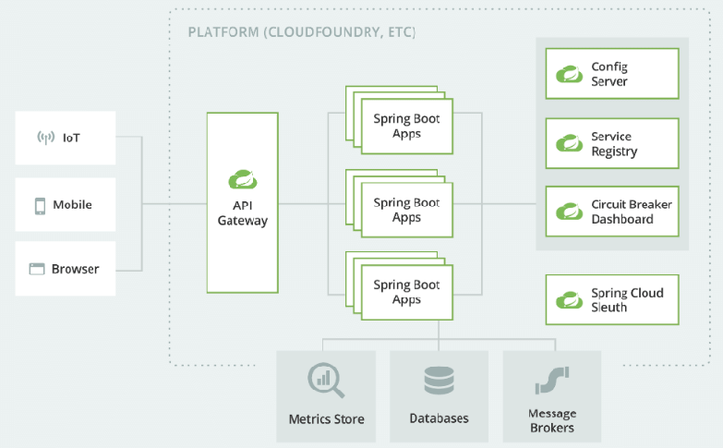
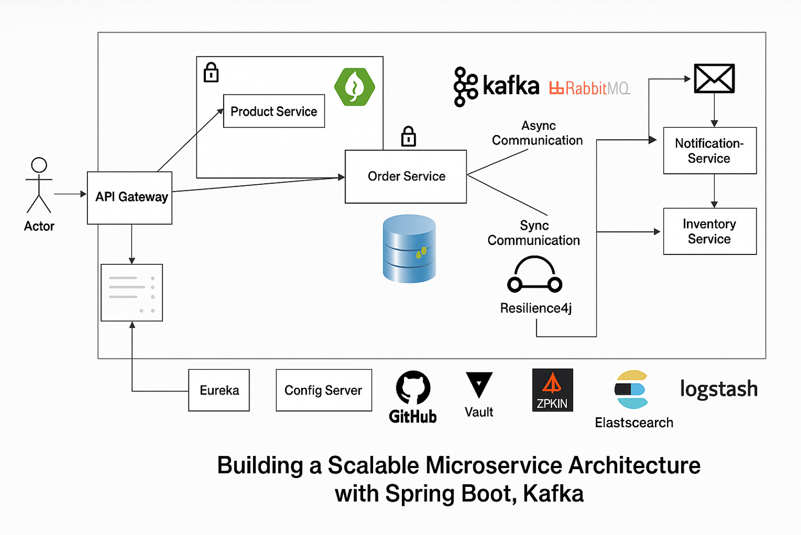

1️⃣ Projects we are creating (Architecture overview)
In a real microservices project, we create multiple independent Spring Boot projects:
Config Server → Centralized configuration
Discovery Server → Service registry (Eureka)
API Gateway → Single entry point for clients
Auth Service → Login, JWT generation, OAuth2
Business Services → User, Admin, Student, etc.
👉 Each one is a separate Spring Boot application
👉 Each one runs on its own port

2️⃣ Config Server – what it REALLY is

✅ Purpose
Central place for all .yml configs
Provides config to all services at startup

❌ What it is NOT
Not an API Gateway
Not a proxy
Not called by clients

🔑 Important points
Config Server is a Spring Boot project
Config repo (local folder / GitHub) is only storage
Services talk to Config Server, not to config repo

3️⃣ Config Repo (local folder or GitHub)

✅ What it is
A place where config files live
Can be:
Local folder (for learning)
GitHub repo (real production)

❌ What it is NOT
Not a runnable project
Not accessed directly by services

Example files:
application.yml
discovery-server.yml
api-gateway.yml
auth-service.yml
user-service.yml

4️⃣ Startup vs Runtime (MOST IMPORTANT CONCEPT)

🟢 Startup phase (ONE TIME)
Happens only when a service starts
Service → Config Server → gets config → starts
Config Server must be UP
Config is loaded into memory

🔵 Runtime phase (EVERY REQUEST)
Client → API Gateway → Eureka → Service
Config Server is NOT involved
Eureka is used for service lookup
👉 This clears the confusion:
❌ Client never hits Config Server
❌ API requests never go to port 8888

5️⃣ Bootstrap.yml vs spring.config.import

Old way (bootstrap.yml)
Used in older Spring Boot versions

New way (latest Spring Boot) ✅
spring:
application:
name: discovery-server

config:
import: "configserver:http://localhost:8888?failFast=true"

🔑 Rule to remember
spring.application.name MUST be local
Rest of config comes from Config Server

6️⃣ Discovery Server (Eureka)

✅ Purpose
Keeps list of running services
Helps API Gateway find services dynamically

Important rules
Eureka does NOT register itself
Eureka UI is accessed directly:
http://localhost:8761

Eureka depends on:
Config Server (at startup only)

7️⃣ API Gateway – role clarified

✅ What API Gateway DOES
Single entry point for clients
Routing requests to services
JWT validation (later)
Uses Eureka to find services

❌ What API Gateway does NOT do
Business logic
JWT generation
Database operations

8️⃣ JWT responsibility split (YOU WERE RIGHT)
Component | Responsibility
Auth Service | Login, OAuth2, JWT generation
API Gateway | JWT validation, expiry check
Business Services | Trust Gateway

9️⃣ Routing concept (client view)
Client always calls ONE PORT:
http://localhost:9090/user-service/api/users/1
Client does NOT know:
Actual service port
Eureka details
API Gateway handles everything

🔟 Startup order of all projects (VERY IMPORTANT)
1️⃣ Config Server
2️⃣ Discovery Server
3️⃣ API Gateway
4️⃣ Auth Service
5️⃣ Business Services

1️⃣1️⃣ What if Config Server goes DOWN?
Situation | Result
Down during service startup | ❌ Service won’t start
Down after startup | ✅ No problem
Client calls APIs | ✅ Works
👉 Config Server is a startup dependency, not runtime

1️⃣2️⃣ Can we skip Config Server and keep configs inside API Gateway?

Answer:
✅ Possible (small projects)
❌ Not recommended (microservices)

Best practice:
Config Repo (Git)
↓
Config Server
↓
All Services

1️⃣3️⃣ Biggest confusions you had (and clarified)
Confusion | Correct understanding
Client hits Config Server | ❌ Never
Folder replaces Config Server | ❌ No
Config Server needed per request | ❌ No
API Gateway depends on Config Server always | ❌ Only at startup
GitHub can replace Config Server | ❌ No

🧠 FINAL GOLDEN RULES (MEMORIZE)
Config Server = startup only
API Gateway = runtime entry point
Client → ONLY API Gateway
Folder/Git = storage, not service
Gateway down = system down

Conclustion : nenu main ga confustion avvindi config server project spring boot anedi yenduku ani dani place lo Folder ni create chesi use cheyachhu ane doubt but ala kudaradu Folder anedi config server project benfits ni replace cheyaledu so oka good microservices project ni build cheyali ante above cheppina project structure anedi manditory
config server ki separate project ni kakunda API gate way project lo kalipi cheyachhu BUT NOT recommended.

Config repo loni properties file lo yedanna chinna changes chesthe entire config repo ni restart cheyalsi vasthunid to avoid this issue What companies use in production in real time ?

Scale / Need | Common Approach | Notes
Small/medium | Config Server + @RefreshScope + /actuator/refresh | Manual refresh is fine
Medium/Large (yekkuva dinni use chesthu vuntaru) | Config Server + Spring Cloud Bus | Automatic propagation to all services
Very large / critical ( baga advanced kavali ante e approach use chestharu ) | Config Server + Feature Flags / dynamic config store | Zero downtime, gradual rollout

